Website Report

Name: Prayag Yuvrajsing And Raboude Loic

Student_ID: 22829 and 22831

Cohort: BSE/21B/FT3

Title: Car Wash Website

Date of submission: 05/08/22

MODULE CODE: WAT1146C

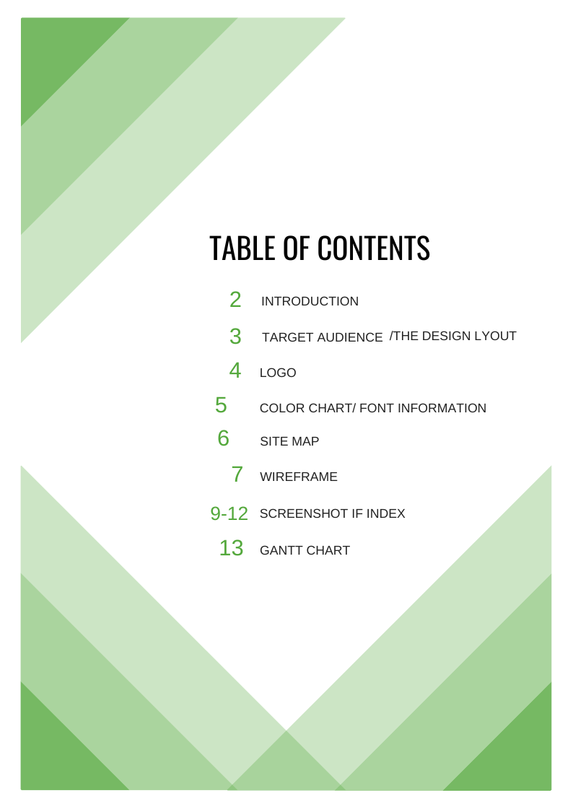

Introduction

A car wash, carwash, or auto wash is a facility used to clean the exterior, and in some cases the interior of motor vehicles. Car washes can be self-service, full-service (with attendants who wash the vehicle), or fully automated (possibly connected to a gas station).

The following are forms of car washing.

• Hand car wash facilities, where the vehicle is washed by employee

• Self-service facilities, generally coin-operated, where the customer manually washes the car with a wand dispersing water and low-pressure brushes, including pressurized "jet washing".

• In-bay automatics involve the customer parking and an automatic wash-machine rolls back and forth over the stationary vehicle. Housed at filling stations and stand-alone wash sites.

• Conveyor or tunnel washes involves the car moving on a conveyor belt through a series of fixed cleaning mechanisms while the customer waits outside. Friction (brushes or curtains) or frictionless (high pressure nozzles and touches wash) are used.

• Mobile car washes, often also serving as mobile detailing systems, carry plastic water tanks and use pressure washers. Often systems are mounted on trailers, on trucks, or in vans. Generally, operators also have a generator to run a shop vac., buffers, and other tool

• Car wash lift, where cars are placed on a lift platform that can be used to wash under the car

• Touch-free (or touchless) car washing technology is the modern car wash system reducing consumption of water, chemical solutions and time. Washing machinery uses high pressure jets that measure the length and width of the vehicle.

//Target Audience:

Our Car Wash website aims to attract the maximum number of customers possible, independently of clients’ social background, age group, or even Gender profile. By the deployment of a panoply of clickable ads through various social media platforms, we hope to attain not only young people but everyone around us.

Are you on a low budget constrain or are you a much more financially independent individual? No worry! Flawless Car Wash is a user-friendly website which provides proper guidance for all those of any educational background. Quick forward, and easily understandable the website offers services varying from the cheapest to the most expensive package.

In addition to that, our new brand service, Mobile Detailing, allows busy clients the opportunity to enjoy the luxury of a detailing service without having to sacrifice convenience. Kick back, relax and enjoy the comfort of your home or office while we make your vehicle look beautiful again.

**//The design Layout:**

For this website a Grid Breaking layout design was adopted as it projects an overall view upon the content of the website, however, customers are not overwhelmed by a multitude number of unnecessary information which would have confused them any further.

The attention is directly drawn to the carousel and different fields of the webpages. Someone once said, “A grid layout arranges contents in a way that our eyes and brains naturally understand, allowing us to digest text and media quickly and efficiently — it’s no wonder that most websites use them.

And I guess that was one of the major reasons why we made this choice.

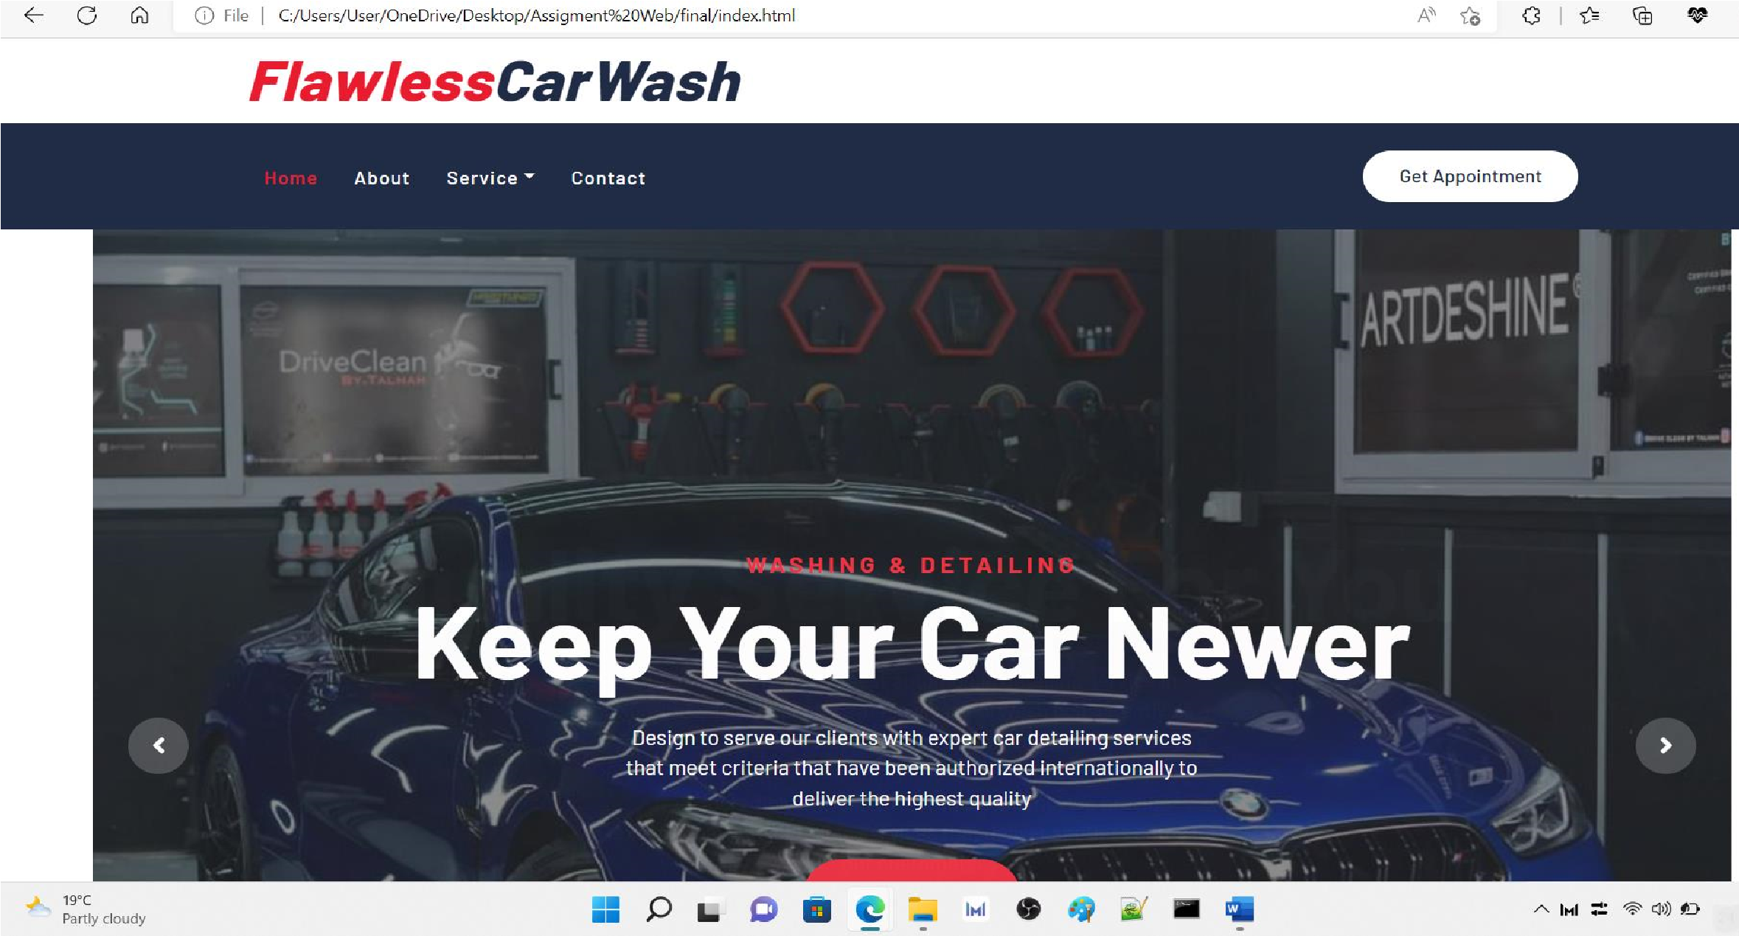

Following off, with our Carwash logo, it is made up of a tender blue color tinted with a white which goes in pair with the theme of the website. To accentuate on the color contrast red color have been used for hovering effects.

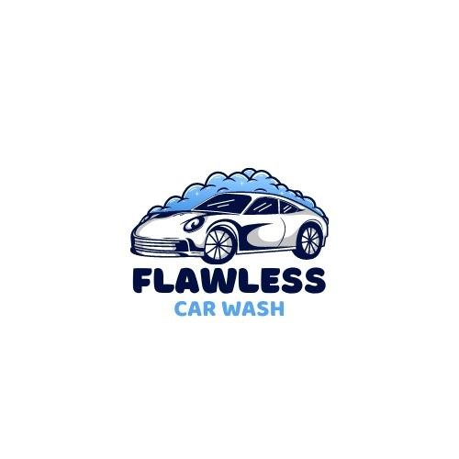

The white color represents our reputation for cleaning your car in a Flawless

Manner whilst, the Color Blue Symbolizes our Trust and Loyalty towards our beloved clients.

**//Color chart and font information:**

Speaking of colors, let’s have an in-depth look of the colors accustomed on the website.

The hexadecimal color code #202c45 is a dark shade of blue. In the RGB color model #202c45 is comprised of 12.55% red, 17.25% green and 27.06% blue. In the HSL color space #202c45 has a hue of 221° (degrees), 37% saturation and 20% lightness. This color has an approximate wavelength of 474.03 nm. Used in the navigation bar,

we tried to contrast this color with a reddish color (html code- #E81C2E) for our hovering effect.

The same color is used in section headers and various parts of the website. (Color information)

Barlow, sans-serif font [body]- is the Font to be used in the most part of the website. (Font Information)

Our main goal is to create a website with minimal variety of color information as possible whilst providing aesthetically represented webpages.

**Sitemap**

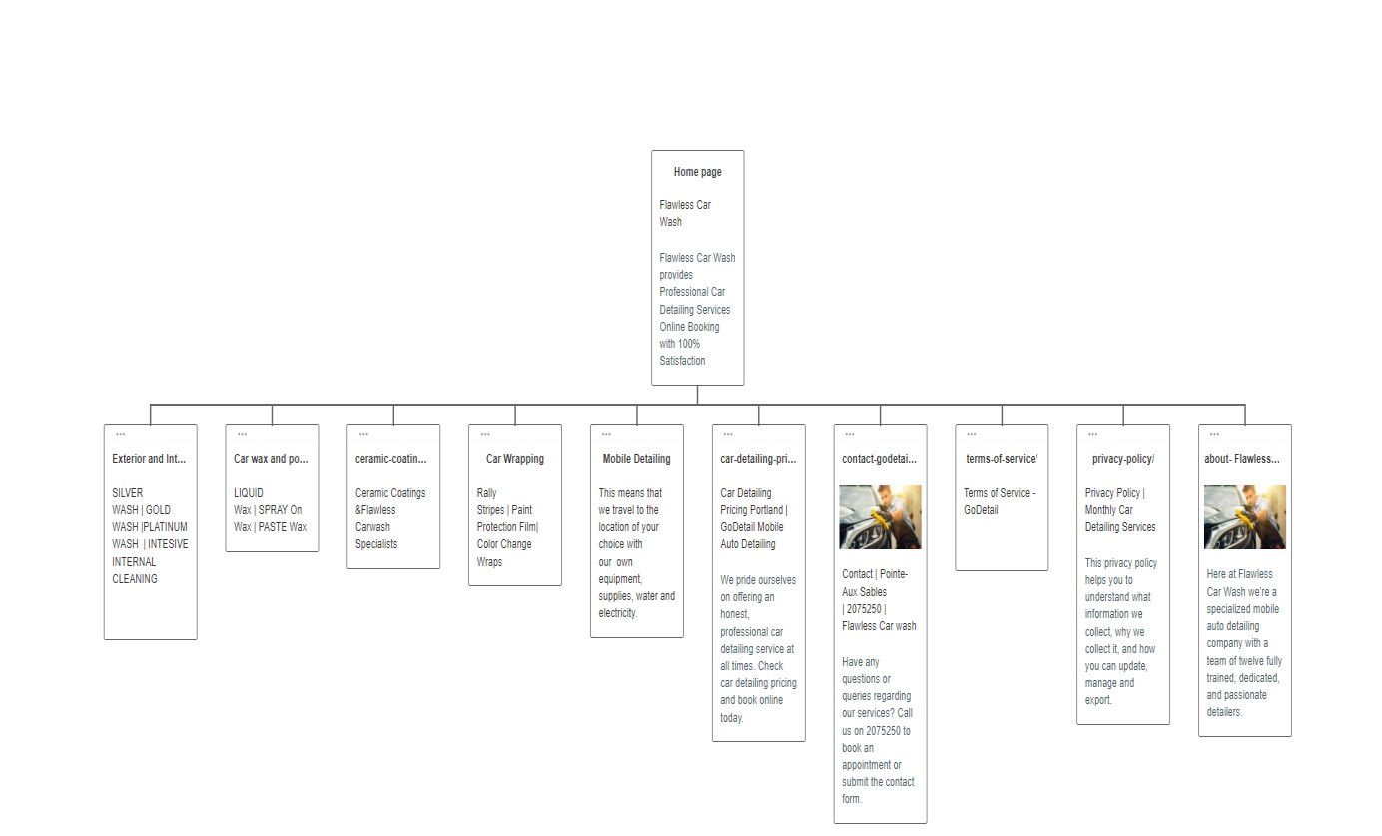

**Wireframe**



Conclusion:

Ending up on a good note Our Car Care Specialist’s take the following precautions & measures to fight against the spread of germs and viruses.

This includes:

* We are vaccinated.
* We wear a mask and gloves during the visit.
* We Disinfect equipment between each job.
* We stay home when we are not feeling well.
* We practice physical distancing when around our customers.

We continually endeavor to give a phenomenal auto enumerating experience for our clients and abandon great work that leaves your vehicle shining. Your vehicle's inside will seem shiny new whenever we are done. Flawless Carwash generally works effectively conveying extraordinary work. You can believe our group to do auto enumerating administrations.

This website is made up of HTML and CSS. The benefits of using these 2 for designing the website was that it was early easy and fast in spite of some problems. I have use CSS to give proper design effects to the HTML we structure that we have created in HTML code.

The most difficult part is to display the picture in the different direction. Consider the picture is in the right direction and the text along with it is the left direction. When we use flex-direction:row-reverse, the image which is on the right side will be shown on the left side and the text will be shown on the right side.

For the website to be responsive that is convenient for small screen devices, I had to make use of @media only screen and (max-width:767px) {}. This has help in adjusting the page according to the size of the screen

To sum up, building the website was quite tough but, in the process, I have learned a lot more about HTML, CSS and BOOTSTRAP

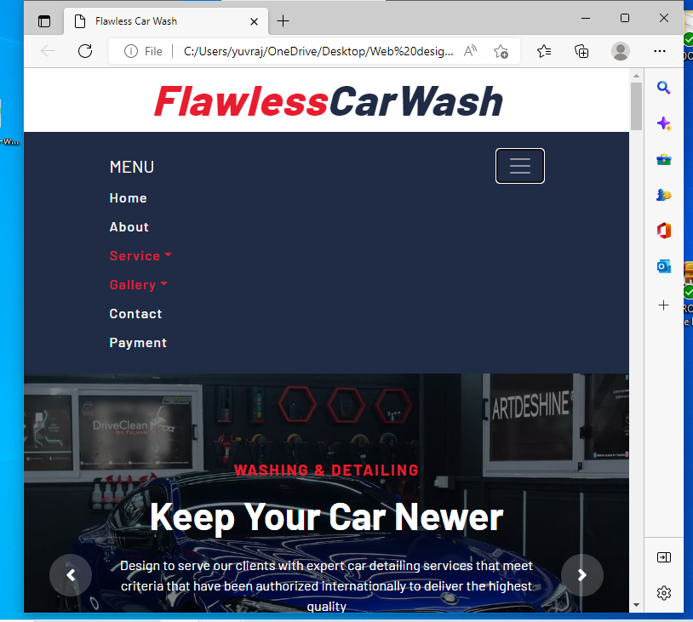

Screenshot of resizing window:

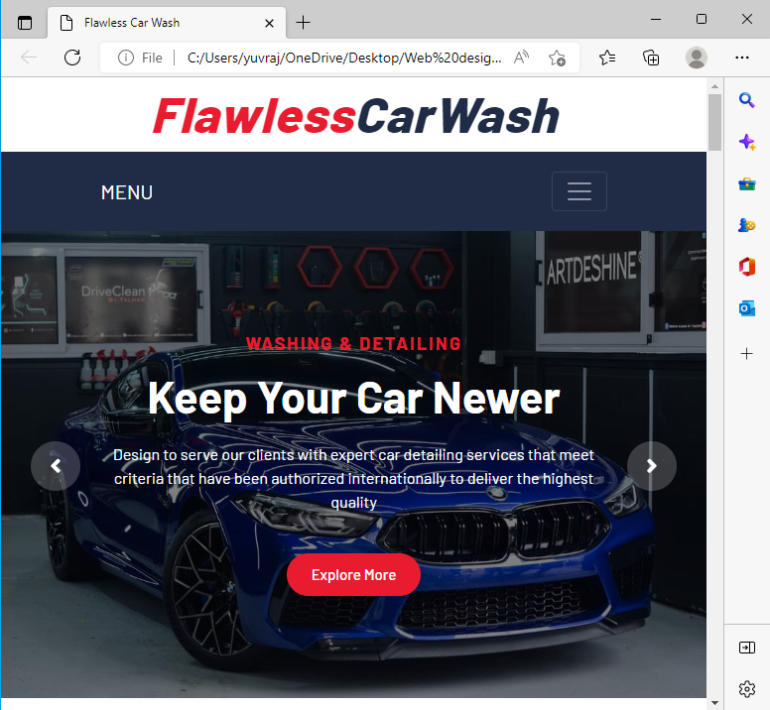

Screenshot of resizing window:

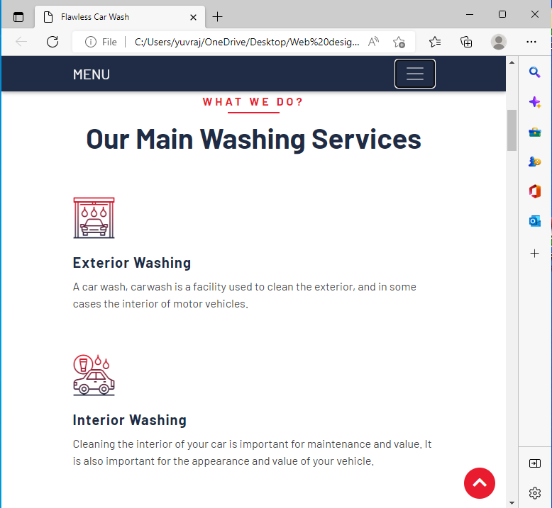

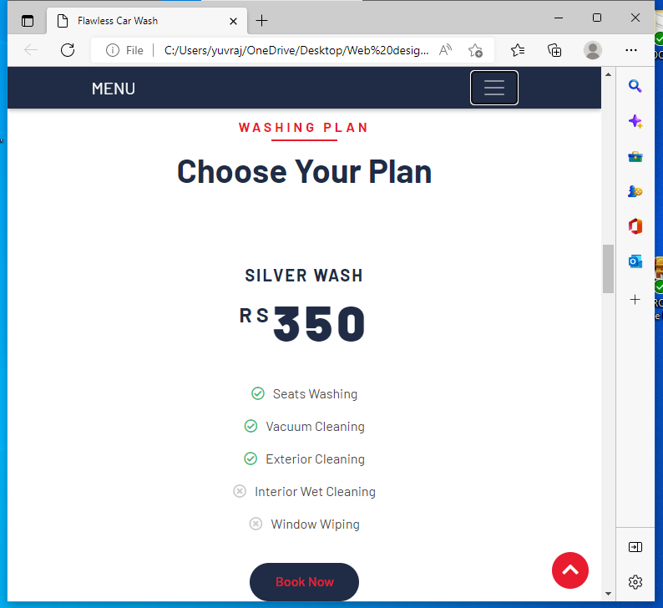

Screenshot of resizing window:

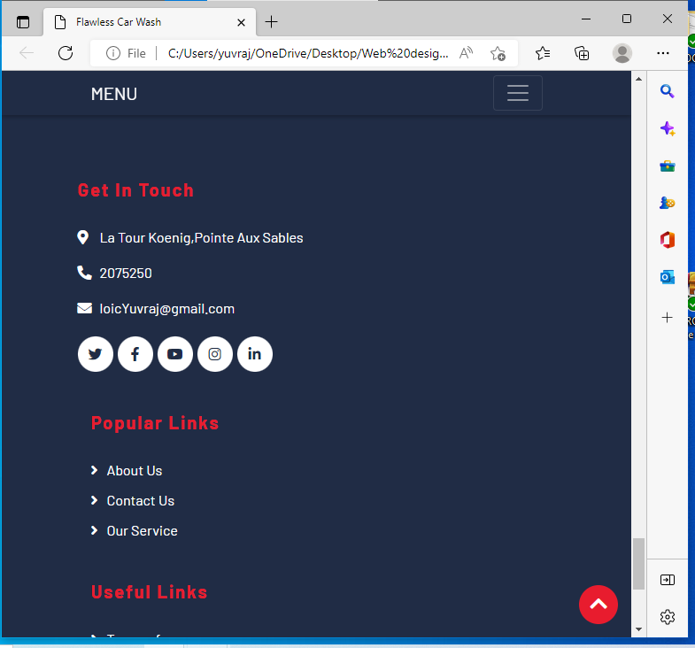

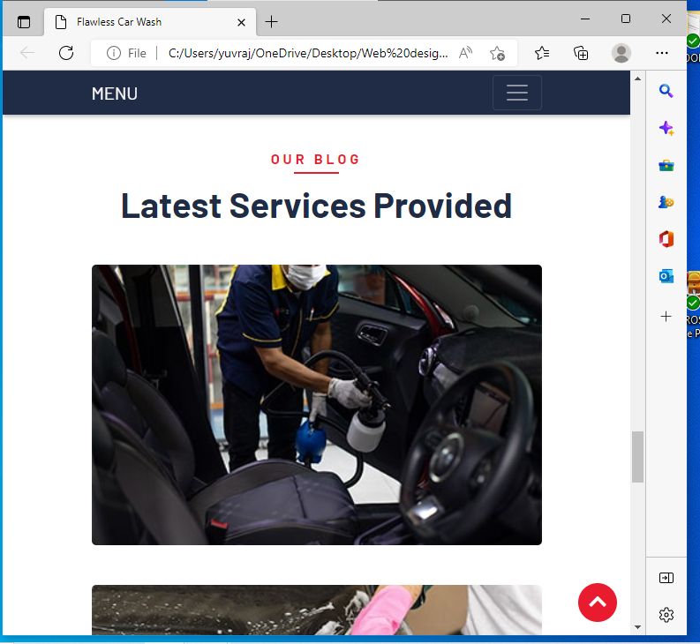

Screenshot of resizing window:

